CUBESAT

* CUBESAT ARCHITECTURE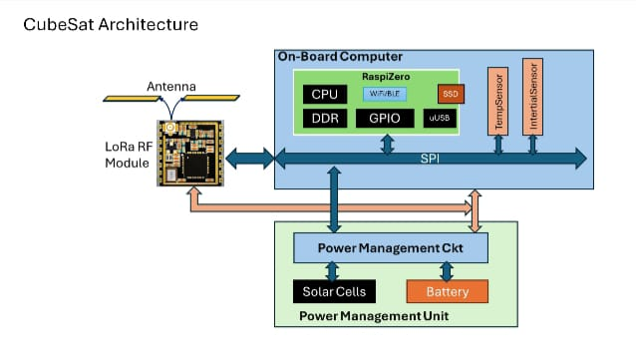
* CUBESAT COMMUNICATION SYSTEM

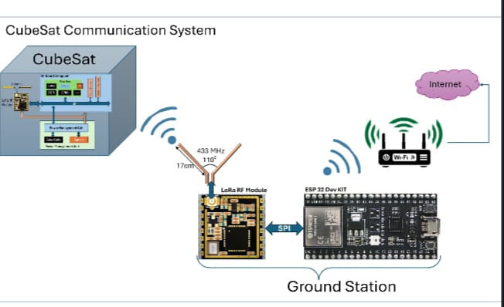

* ESPN32 DEVELOPMENT BOARD-

